Project Design Phase-II
Technology Stack (Architecture & Stack)

Date | 27 June 2025
Team ID | LTVIP2025TMID59839
Project Name | Pattern Sense: Classifying Fabric Patterns Using Deep Learning
Maximum Marks | 4 Marks

Technical Architecture:
The Deliverable shall include the architectural diagram as below and the information as per the table1 & table 2
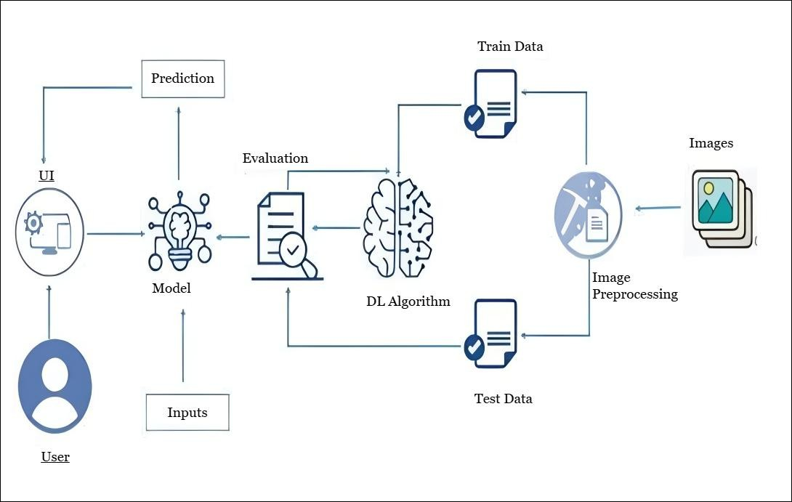

Table-1: Components & Technologies:

S.No | Component | Description | Technology
1. | User Interface | How user interacts with application (Web Page) | HTML, CSS, Bootstrap, Flask (Python)
2. | Application Logic | Logic for a process in the application | Python
3. | File Storage | File storage requirements | Stores predicted images in Local Filesystem
4. | Machine Learning Model | Purpose of Machine Learning Model | ResNet
5. | Data | Data used to train the model | Dataset from Kaggle

Table-2: Application Characteristics:

S.No | Characteristics | Description | Technology
1. | User-Friendly Interface | Simple, intuitive web interface for image upload and result visualization. | HTML, CSS, Bootstrap, Flask (Python)
2. | Real-Time Prediction | Immediate classification of produce as healthy or rotten. | Flask backend, TensorFlow model
3. | Extendable Dataset  Suppor | N ew produce types can be added by updating the dataset and retraining. | ImageDataGenerator, Keras, TensorFlow
4. | Efficient Processing | Optimized ResNet model ensures fast and reliable predictions. | Pre-trained ResNet, Numpy

